Institut für Anglistik

Prof. Dr. Greta Olson

October 2023

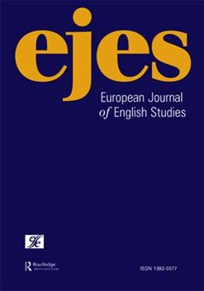

**Call for Topics for the *European Journal of English Studies* (Volume 30 to be published in 2026)**

**The *European Journal of English Studies*** is calling for proposals for the topics of special issues of the journal that will be published in 2026. EJESpresents work of the highest quality in Anglophone critical theory, literary, linguistic, cultural, media, and sexuality studies. This coheres with the plurality of English and Anglophone studies in Europe and relates to the journal’s association with the European Society for the Study of English.

Pronounced “edges,” the journal takes an interest in topics that investigate borders and overlaps between interdisciplinary scholarship in English and Anglophone Studies. We take a broadly questioning stance towards “English” and “English Studies” and wish to promote dialogue between the disciplines and cultural traditions of inquiry relating to these studies. “European” then describes situations in which “English” is studied and taught in a variety of Anglophone and non-Anglophone contexts.

The general editors encourage proposals for special issue topics that span divides between critical and cultural theory, literary analysis, and linguistics as well as gender and sexuality studies. Ideally, these topics will also reflect on English and Anglophone Studies within Europe. Guest editing teams should be comprised of two or three persons working in different localities within Europe who have significant editing experience.

In some cases, EJES publishes volumes that result out of conferences. These proposals can be considered if the resulting CFP is opened up to scholars who did not participate in the original conference. Suggestions for topics can be made to the editors at any time.

Greta Olson (Justus Liebig University of Giessen): [greta.olson@anglistik.uni-giessen.de](mailto:greta.olson@anglistik.uni-giessen.de)

Isabel Carrera Suárez (University of Oviedo): [icarrera@uniovi.es](mailto:icarrera@uniovi.es)

Katerina Kitsi-Mitakou (Artistotle University of Thessaloniki): [katkit@enl.auth.gr](mailto:katkit@enl.auth.gr)

Frederik Van Dam (Radboud University, Nijmegen): frederik.vandam@ru.nl

#### **Procedure**

1. Potential guest editors submit a Call for Papers of 300 to 500 words for their topic to the general editors. This includes a list of leading questions. See the current CFPs or the example here for a suggested form. Brief bios of the guest editors should be included that demonstrate their editing experience.
2. The general editors select new topics for the issues. The chosen CFPs are edited to cohere with EJES’s aims.
3. During the following calendar year, the resulting CFPs are distributed widely, and potential submissions are collected by the end of November of that year and are reviewed by the guest and general editors.
4. Selected authors are then invited to submit full-length essays of between 6,000 and 8,000 words. These essays are peer-reviewed and appear in the EJES issues that are published in the following year.